

Project Name: Paperless School Management System

Branch E-DAC Sept-2021

Documentation On

**“ONLINE PG RENTAL SYSTEM”**

E-DAC MAY 2021

**Guided By: Monika Shivankar**

Submitted By :

**Group No: 15**

* **Priya Kotecha 210543081047**
* **Ankur Mahalle 210543081052**
* **Rajshree Patil 210543081074**
* **Ashiph Sayyad 210543081095**

**Table of Contents**

**1. Introduction 4**

1.1 Document Purpose **4**

1.2 Project Background **4**

1.3 Aim & Objectives **4**

**2. Business RequirementsOverview**…………………………………………………………**5**

**3.Functional Requirements** **5**

3.1 Landlord/Owner Module **5**

3.2 Tenant Module **5**

3.3 Admin Module **6**

**4.Non-FunctionalRequirement………………………………………………………………6**

**5. Use Case Diagram 7**

5.1 Admin **7**

5.2 Tenant **8**

5.3 Landlord/Owner **9**

**6. Database Design 10**

1 Registered User **10**

2 Landlord **10**

3 Tenant…………………………………………………………………………………… ………..**10**

4 Properties **10**

5 Images **11**

6 Transaction **11**

**7.E-R Diagram………………………………………………………………………………………12**

**8. Snapshots 13**

**9. Conclusion 23**

**List of Figures**

Use Case Diagrams 7

Fig 1 Admin 7

Fig 2 Tenant 8

Fig 3 Landlord/Owner 9

Fig 4 ER Diagram 12

1. **Introduction:**
   1. **DocumentPurpose:**

This document communicates the business requirements and scope for developing Online PG Rental System. The scope of this document is to define the functional and non-functional requirements, business rules and other constraints requirements.

## Project Background:

Currently on the web there are many sites available which provides properties on rent. But the search is limited to individual properties or bulk properties such as flats, hostels, houses. Also, the status of the available/occupied properties are not updated on those websites. Generally, the contacts available for inquiry of the properties are of brokers so user has to contact the broker and pay the brokerage. There is no transparency. Some of the individual properties are not available on such kind of websites which are mainly available for individual in the nearby vicinity.

## Aim & Objectives:

The main objective of this project is building a website for individual users who are looking for the properties on PG basis.

This project will help the users to modify their search for PG rentals in the nearby vicinity. Here in this system any individual landlord/owner can easily upload their property details and also can update the status of their property. So, the user will be able to access the details of any property and can contact the owner of the property. Also, the user will be able to see the current status of the updated properties.

1. **Business RequirementsOverview:**

* Online PG Rental System is the public web application.
* Online PG Rental System will be opened to the global, but in the phase 1, the main target is limited to a specific city.
* There are mainly two types of users. One is the Tenant and other is Owner/Landlord.
* Tenants can search for the properties available on PG/Rent basis
* Tenants can search for the properties available.
* This system provides the functions which connect the tenants and the owners/landlords efficiently.
* This system could be maintained by Administrator.

# Functional RequirementsOverview:

Online PG Rental System consists of four modules described as below.

1. Tenant Module
2. Owner/Landlord Module
3. Admin Module

# 3.1 Tenant Module

* Tenant can register and create his own account.
* This system provides the function which allows Tenants to search the properties.
* Tenant is able to browse through all existing properties.
* The Tenant could find what are pricing and details of all properties.

# 3.2 Owner/Landlord Module

* Owner/Landlord can register and create his own account.
* This system provides the function which allows Owner/Landlord to upload the property details.
* They could delete the properties.

# 3.3 Admin Module

* This system should provide all function to admin how to handle the System.
* The properties of the owner/landlord uploaded on this system are authorized.
* Could able to know all the Transaction.

# 4. Non-functional Requirements

* The website should use professional design, look and feel and color scheme.
* Users will have no limitations for accessing the application through Internet. The portal being an internet application, it is difficult specify exact number of visitor or users. Hence, we will target the system to support between 5 and 10 thousands of users on launch of phase 1.
* Being a public website, the site must follow general usability guidelines for menus, navigation, colors, links and other actions provided on the screens.
* The system should be designed in such a manner that user will be able to complete tasks in minimum number of steps.

.

## 5. Use-CaseDiagram

**5.1 Admin:**

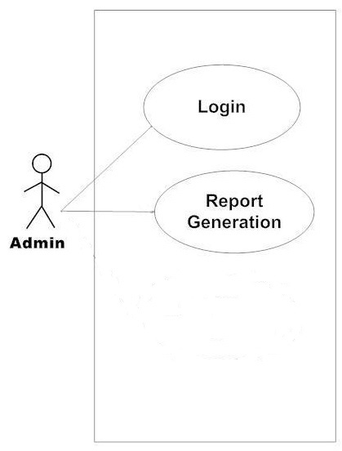

Fig. Use-Case Diagram for Admin

## 5.2 Tenant:

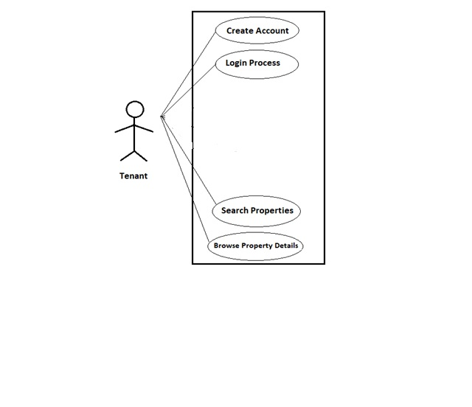

Fig. Use-Case Diagram for Tenant

**5.3 Landlord/Owner:**  
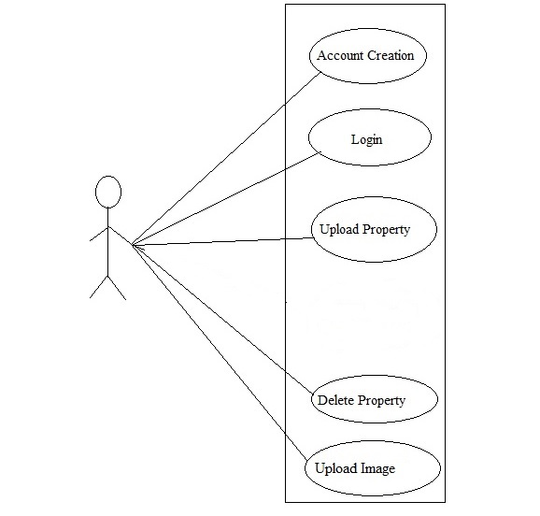

Fig. Use-Case Diagram for LandLord/Owner.

**6. Database Design:**

**1] Registered_user Table**

|  |  |  |  |  |  |
| --- | --- | --- | --- | --- | --- |
| **Field** | **Type** | **Null** | **Key** | **Default** | **Description** |
| user_id | Integer | No | Primary key |  | User ID |
| email_id | Varchar(20) | No |  |  | Email ID Of User |
| user_type | Varchar(20) | No |  |  | Type of User |
| Password | Varchar(15) | No |  |  | Account Password |

**2] Landlord Table**

|  |  |  |  |  |  |
| --- | --- | --- | --- | --- | --- |
| **Field** | **Type** | **Null** | **Key** | **Default** | **Description** |
| lid | Integer | No | Primary key |  | Landlord id |
| User_id | Integer | No |  |  | User id |
| fname | Varchar(45) | No |  |  | Landlord’s first name |
| lname | Varchar(45) | No |  |  | Landlord’s last name |

**3] Tenant Table**

|  |  |  |  |  |  |
| --- | --- | --- | --- | --- | --- |
| **Field** | **Type** | **Null** | **Key** | **Default** | **Description** |
| tid | Integer | No | Primary key |  | Tenant id |
| user_id | Integer | No |  |  | User id |
| fname | Varchar(45) | Yes |  | Null | Tenants first name |
| lname | Varchar(45) | Yes |  | Null | Tenants last name |

**4]Properties Table**

|  |  |  |  |  |  |
| --- | --- | --- | --- | --- | --- |
| **Field** | **Type** | **Null** | **Key** | **Default** | **Description** |
| pr_id | Integer | No | Primary key |  | Id of the property registered |
| lid | Integer | No | Primary Key |  | User id of User |
| pr_type | Varchar(45) | No |  |  | Type of property |
| area | Varchar(45) | No |  |  | Area of the property |
| city | Varchar(45) | No |  |  | City in which property resides |
| user | Varchar(45) | Yes |  | Null | User |
| rent | Integer | Yes |  | Null | Rent of property |
| brokerage | Float | Yes |  | Null | Brokerage on the property |
| facilities | Varchar(100) | Yes |  | Null | Facilities available in the property |
| status | Integer | Yes |  | Null | Status of property |

**5] Images Table**

|  |  |  |  |  |  |
| --- | --- | --- | --- | --- | --- |
| **Field** | **Type** | **Null** | **Key** | **Default** | **Description** |
| img_id | Integer | No | Primary key |  | Image Id |
| pr_id | Integer | No | Primary key |  | Property ID |
| name | Varchar(45) | No |  |  | Name must be given to image |
| type | Varchar(45) | No |  |  | Type of image |
| pic_bytes | LONGBLOB | Yes |  | Null | Image bytes. |

**6] Transaction Table**

|  |  |  |  |  |  |
| --- | --- | --- | --- | --- | --- |
| **Field** | **Type** | **Null** | **Key** | **Default** | **Description** |
| oid | Integer | No | Primary key |  | Order id |
| tid | Integer | No | Primary key |  | Tenant id |
| pr_id | Integer | No | Primary key |  | Property id |
| rent | Integer | No |  |  | Rent of property |
| brokerage | Float | No |  |  | Brokerage on the property |
| status | Integer | No |  |  | Status of property |
| total_amt | Float | No |  |  | Total amount to be paid |

## 7. ER-Diagram:

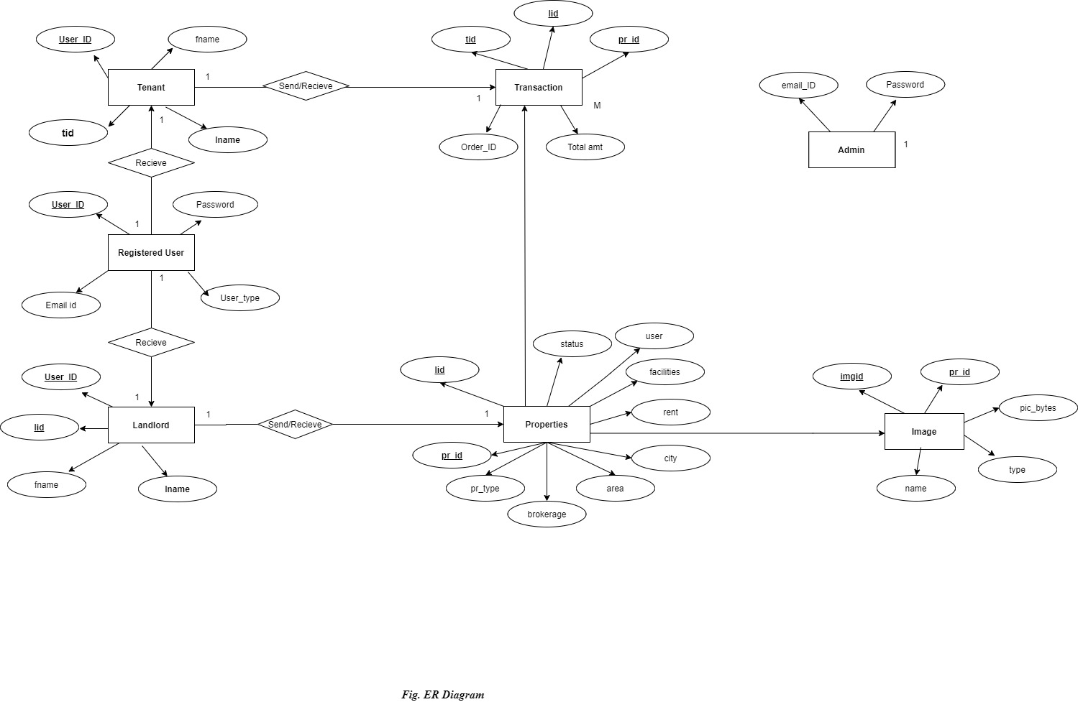

**E-R diagram shows database ofOnline PG Rental System**

**8. Snapshots:**

**8.1 Home Page:**

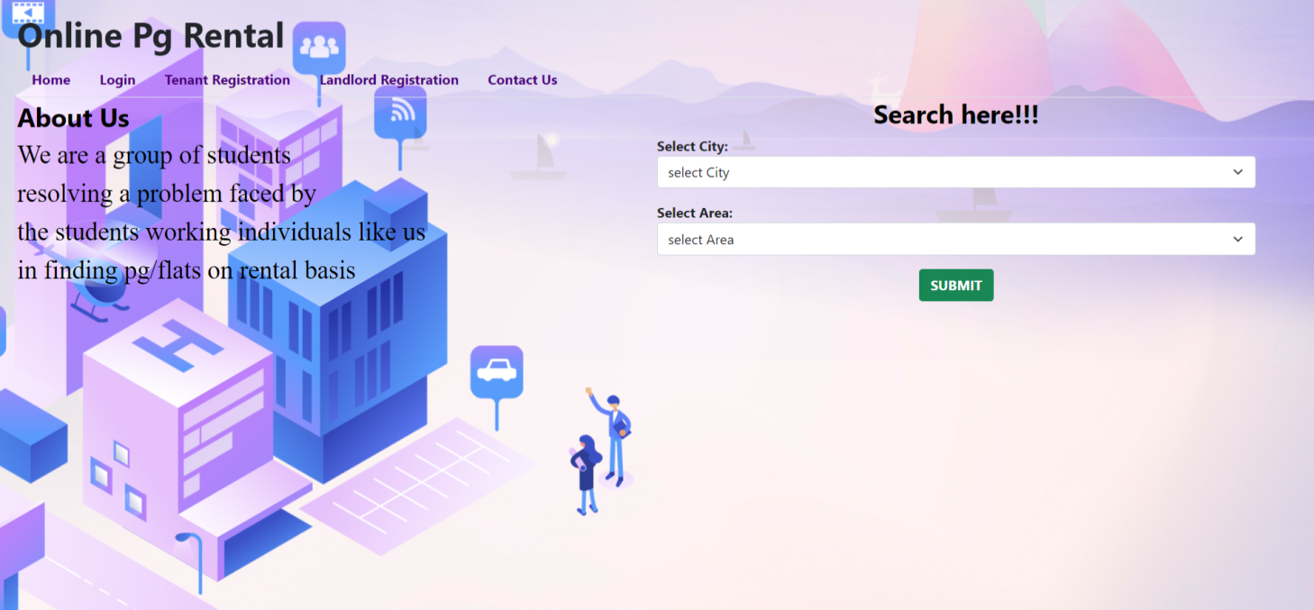

This page contains following controls

* Home
* Login
* Tenant Registration
* Landlord Registration
* Contact Us

**8.2 Contact Page**

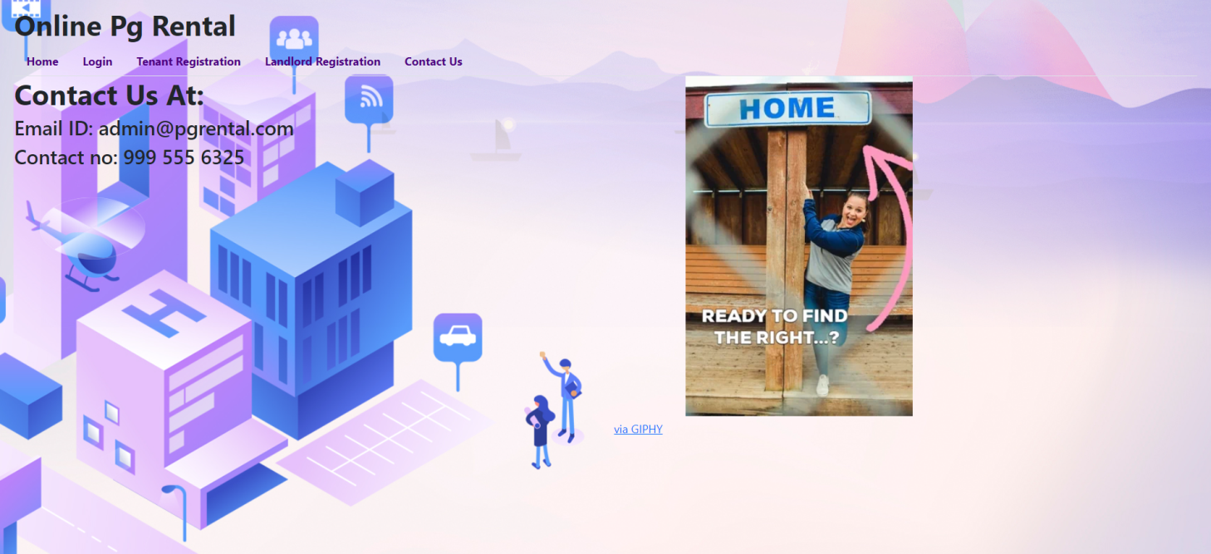

**8.3Login Page**

Following snapshot shows the Login page for Online PG RentalSystem

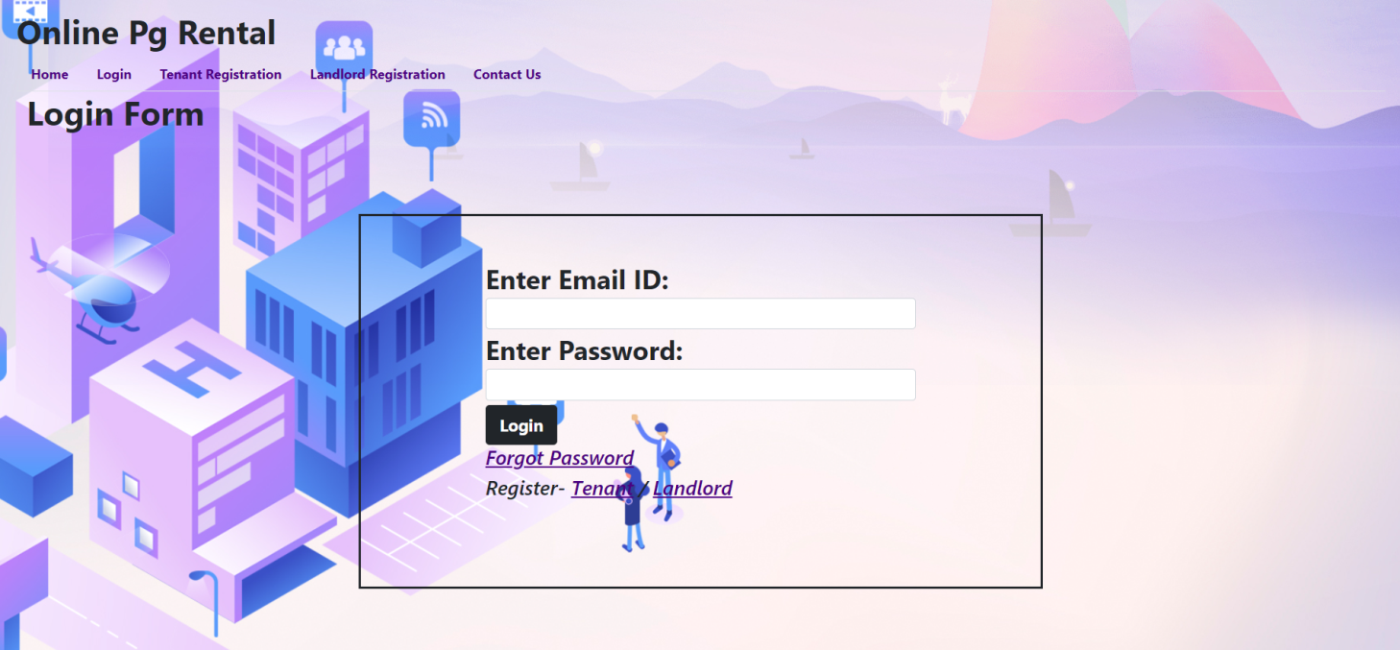

**8.4Landlord Registration Page**

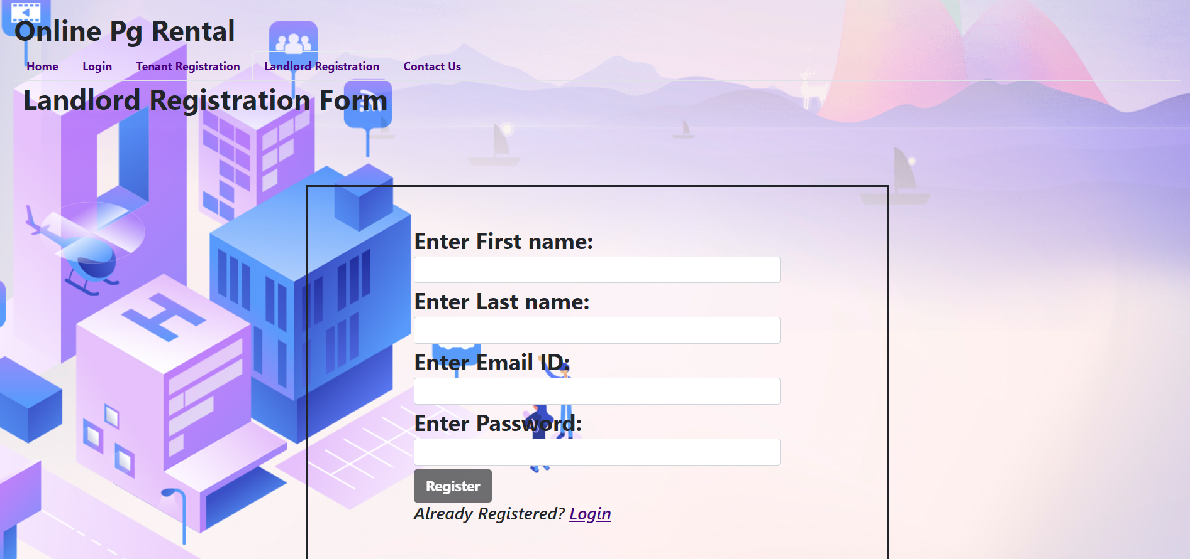

* User will get registered as Landlord/Owner.

**8.4.1 Landlord Add Property Page**

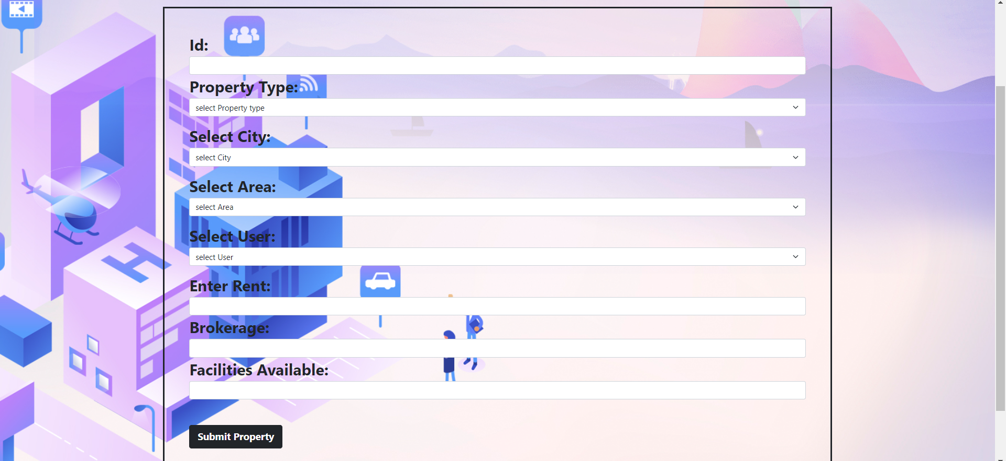

**8.4.2 Landlord Property Image Upload Page**

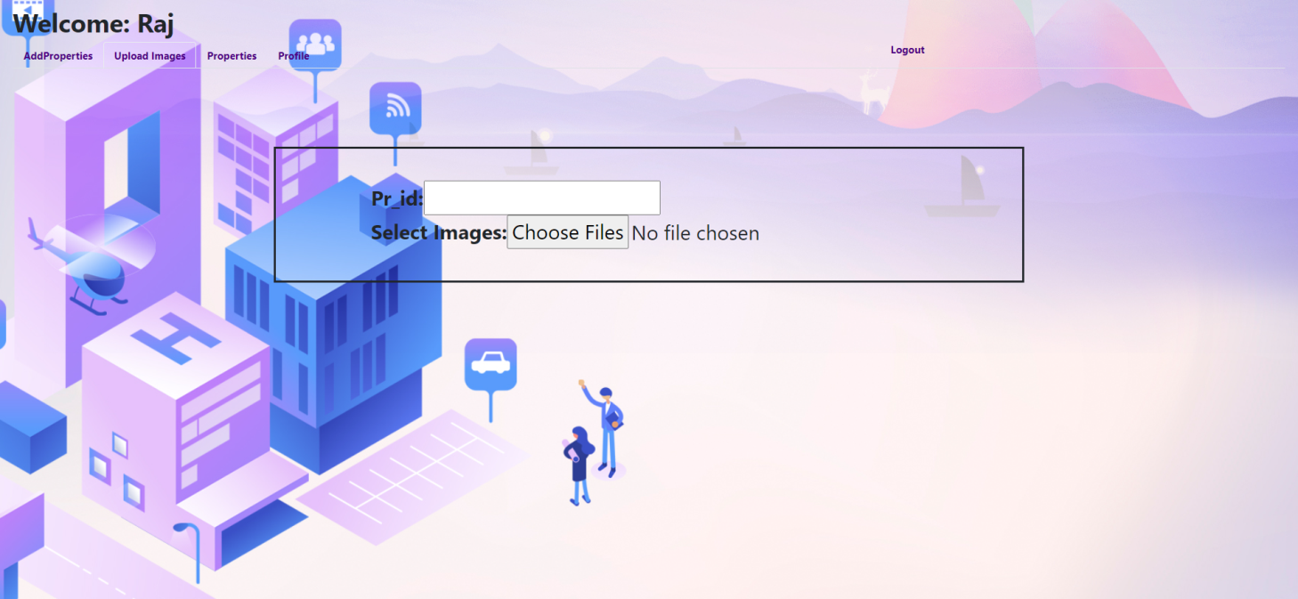

**8.4.3 Landlord Properties(Uploaded)**

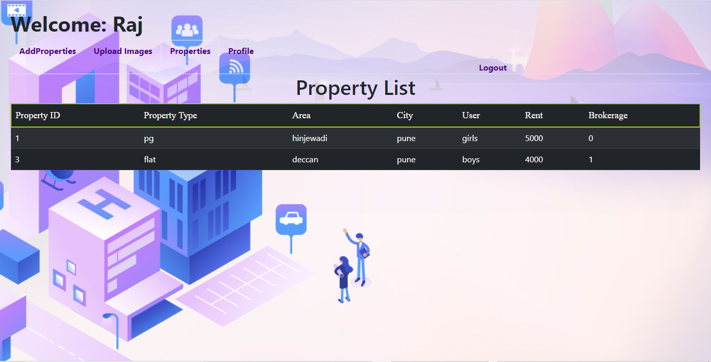

**8.4.3 Landlord Profile Page**

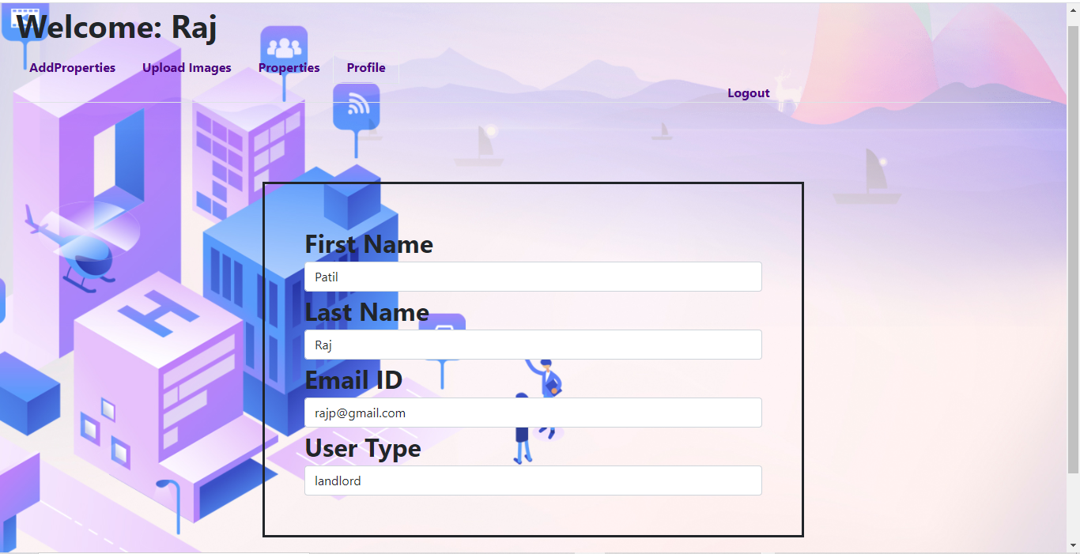

**8.5Tenant Registration Page**

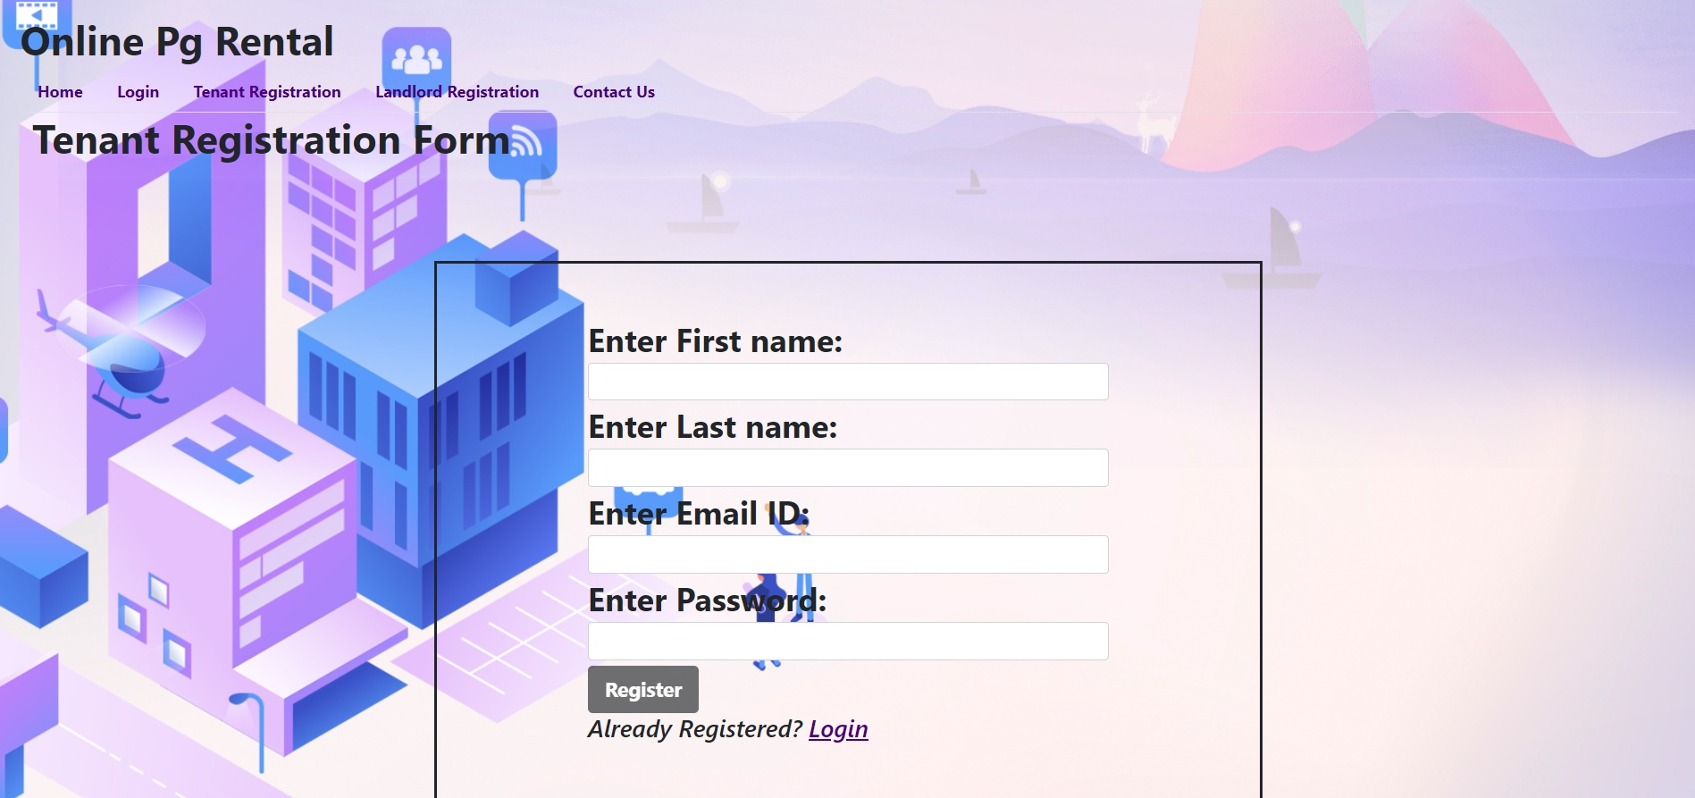

**8.5.1Tenant Home Page**

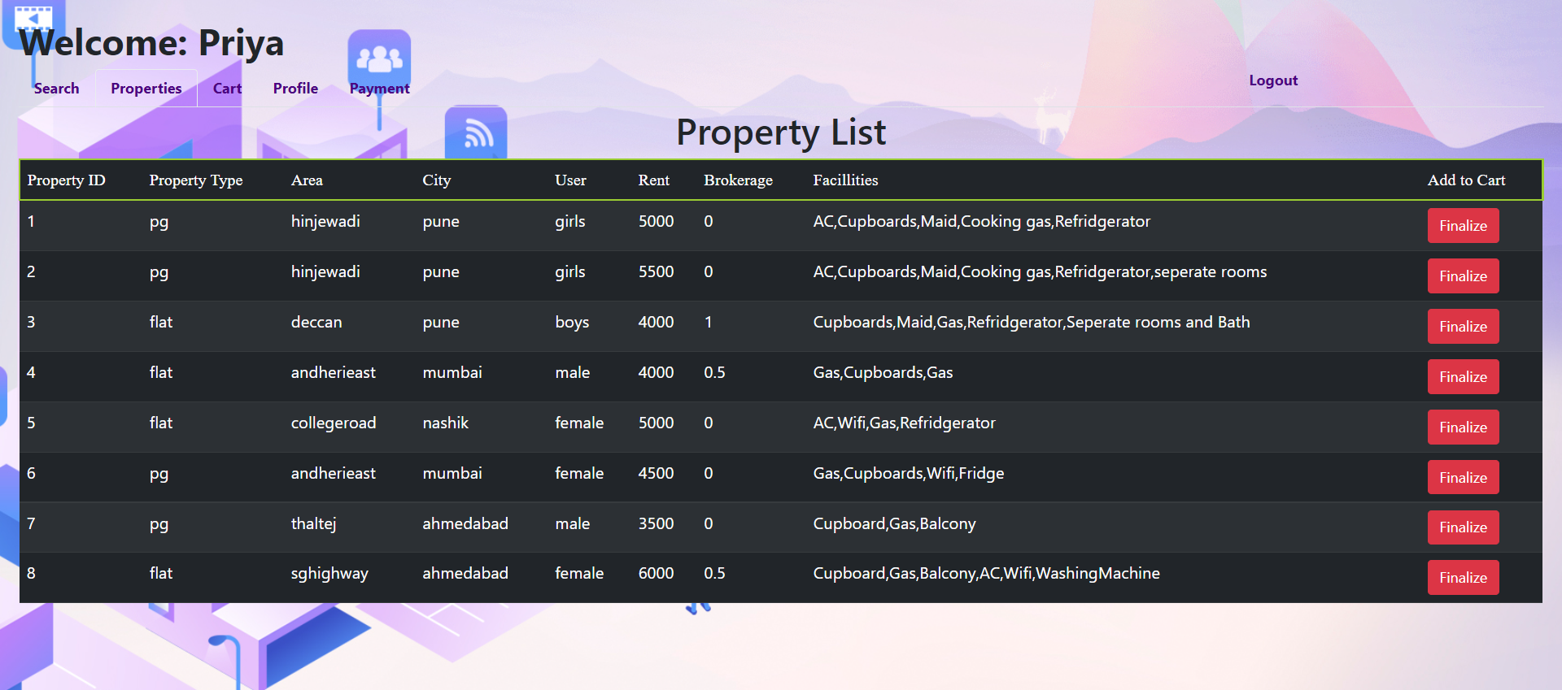

**8.5.2 Tenant Search Result Page**

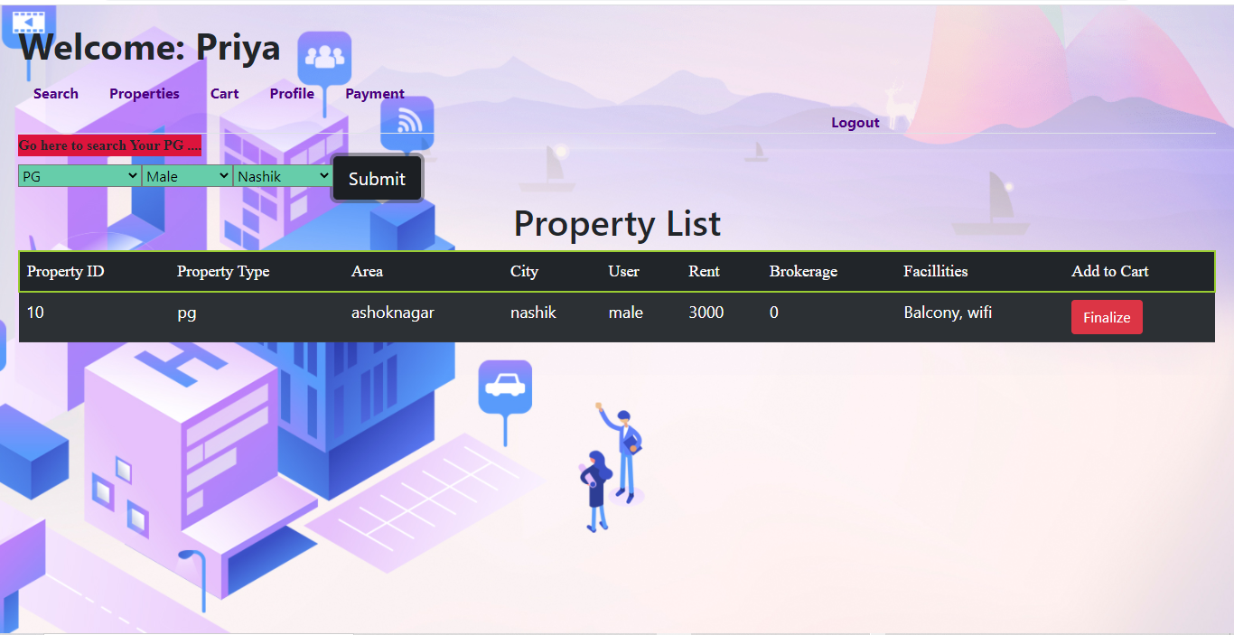

**8.5.3 Tenant Profile Page**

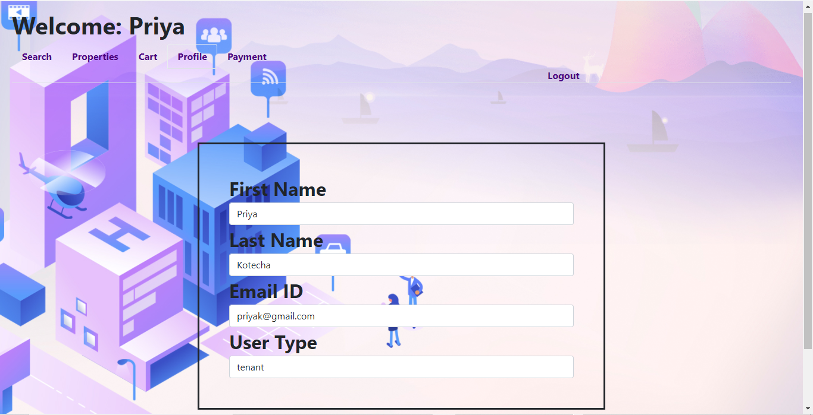

**8.5.4 Tenant Cart Page**

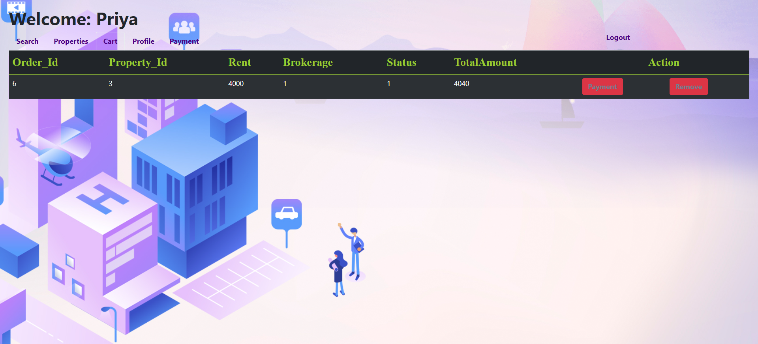

**8.5.5 Tenant Payment Page**

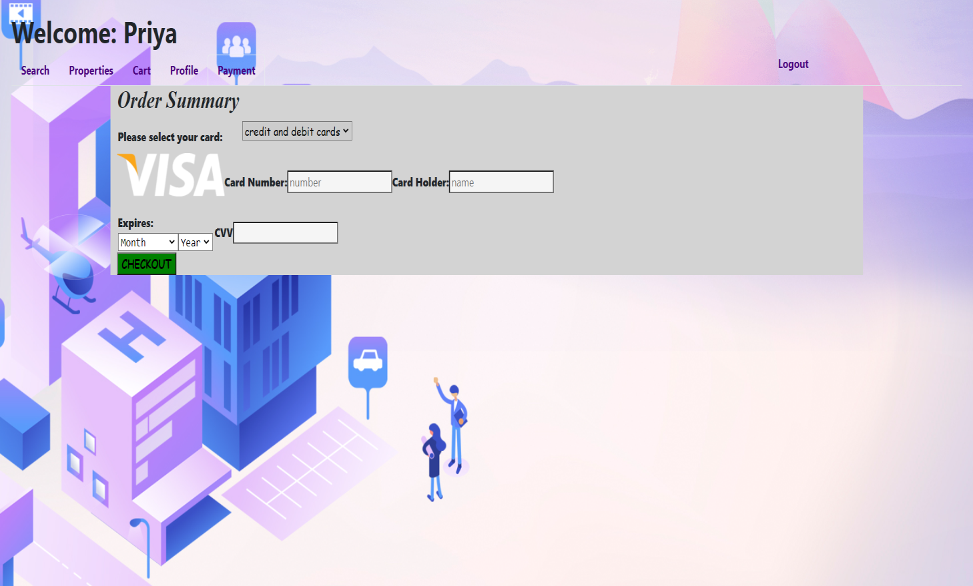

**8.6Admin Page**

**8.6.1 View Registered User List**

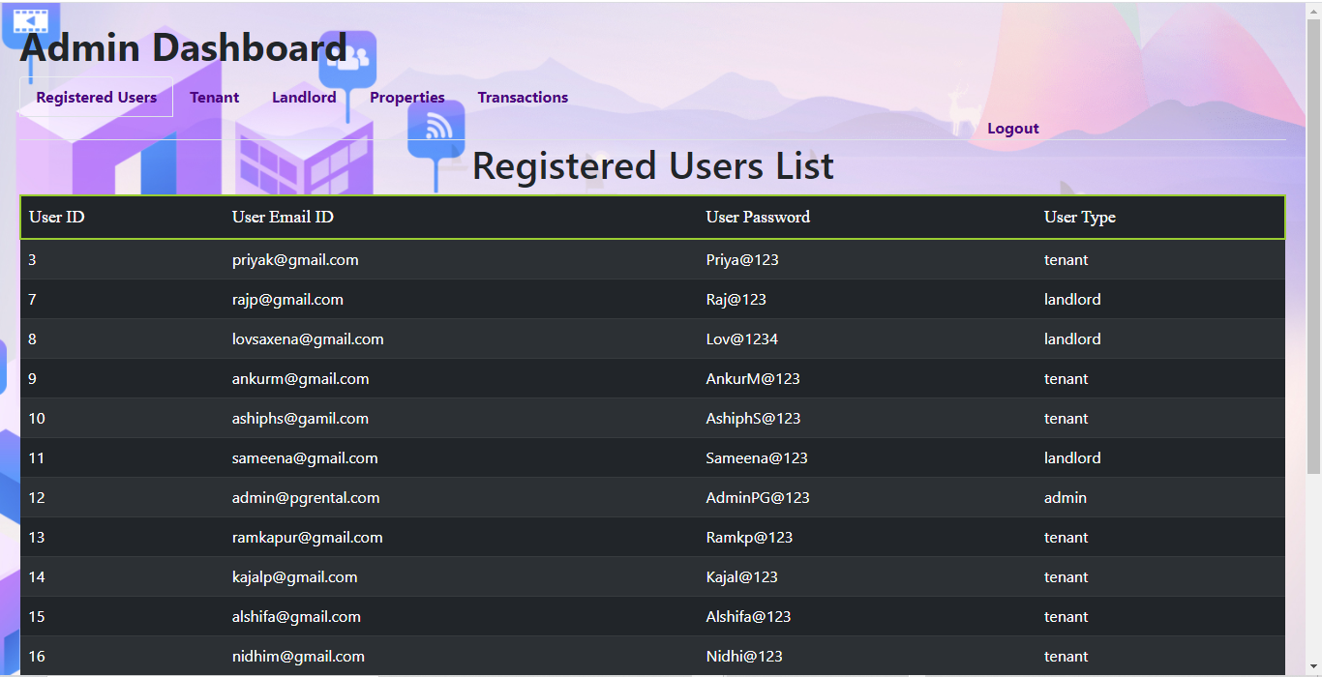

**8.6.2 View Registered Tenant List**

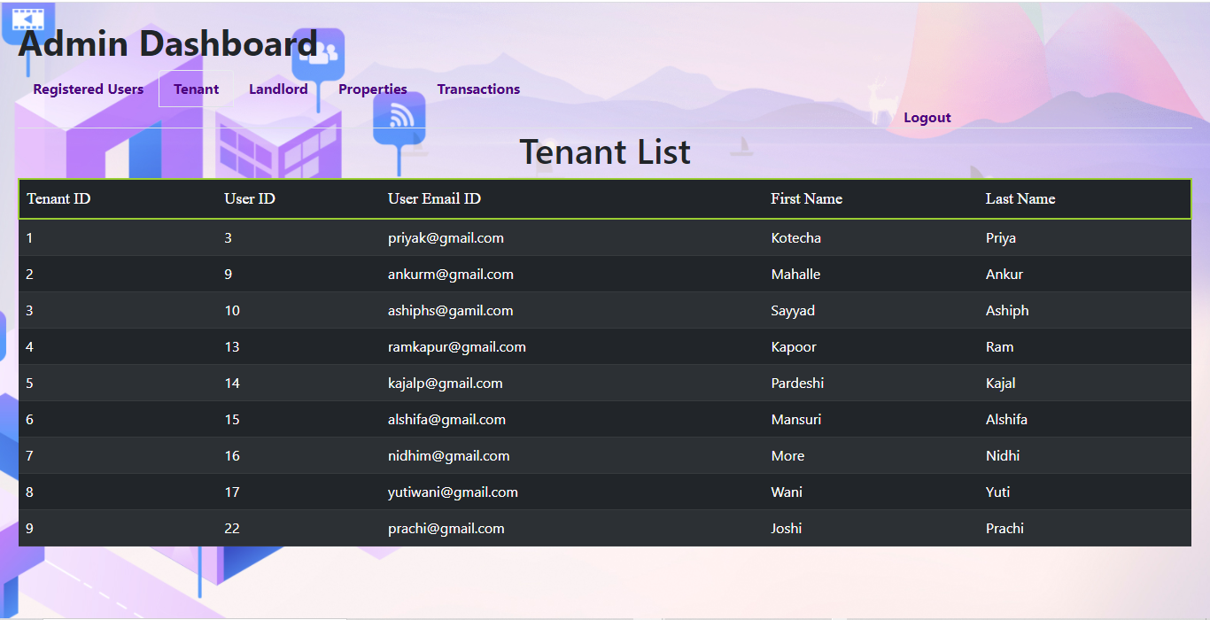

**8.6.3View Registered Landlord List**

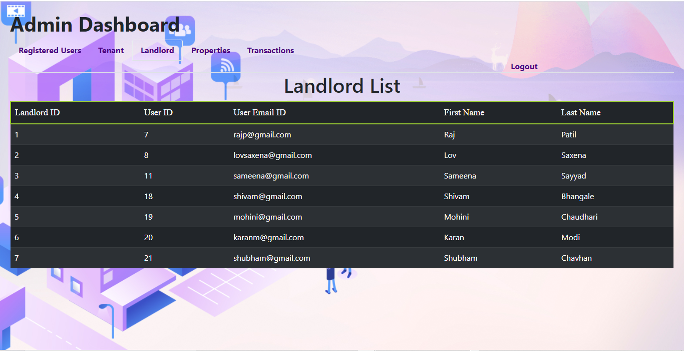

**8.6.4 View Registered Properties**

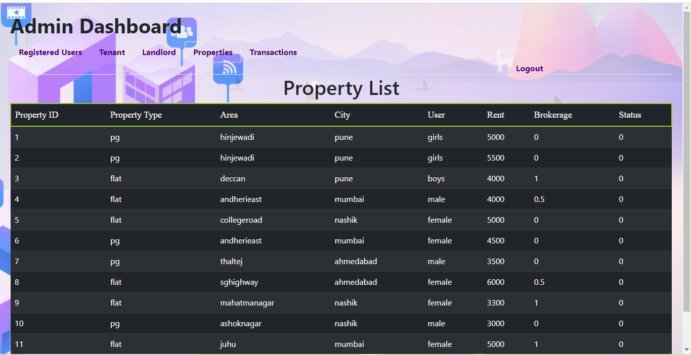

**8.6.5View Transaction List Page**

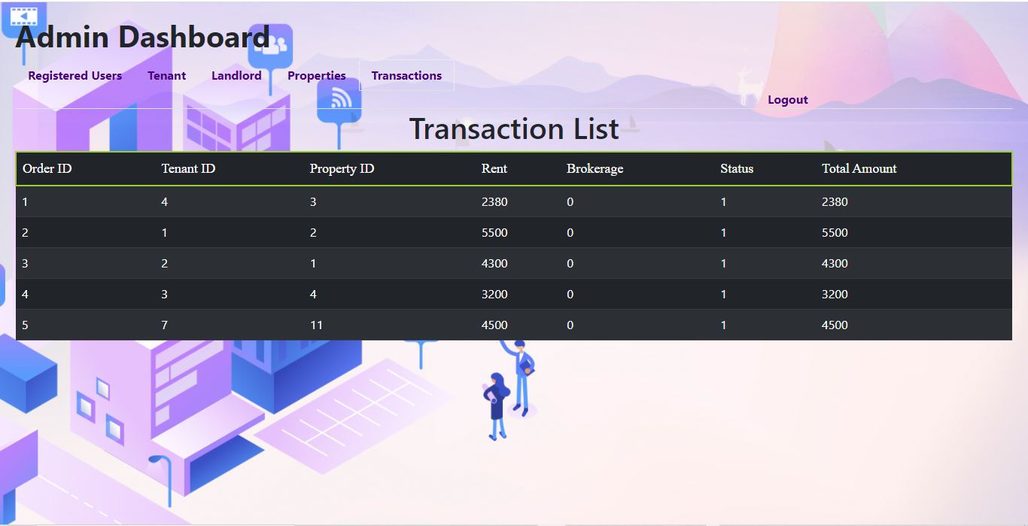

**9.CONCLUSION AND FUTURESCOPE**

Online PG Rental System helps to connect PG tenants with Landlords/Owners efficiently.

Our System provides a very user-friendly platform where Tenant can easily search for the property which available for rent on PG basis also Landlord will be able to upload various properties which are available on rent.

In future our project is meant to satisfy the needs of rental house owners. Several user friendly interfaces have also been adopted. This package shall prove to be a powerful in satisfying all the requirements of the users.